**Vulnerability Report : BATA.com**

Presented by: - MOHAMMAD TAFAZUL ARFA

URL: - https://www.bata.com/in/

**Table of Contents**

1. Organization Details ............................................................... 2
2. Domain Information .............................................................. 3
3. Server Details ........................................................................ 4
4. Technologies Used ................................................................. 5
5. Security Configurations .......................................................... 6
6. Recommendations .............................................................. 6 – 7
7. Domain health report ………………………………………………………. 8

**Index:**

1. Organization Details
2. Domain Information
3. Server Details
4. Technologies Used
5. Security Configurations
6. Recommendations
7. **Organization Details:**
8. **Founder**:- Antonín Baťa Tomáš Baťa Anna Baťová (No linkedin acc found)
9. **CEO**:- Sandeep Kataria (<https://www.linkedin.com/in/sandeep-kataria-31928b1/?originalSubdomain=ch>)
   1. **About CEO**:- About Sandeep Kataria
   2. Sandeep Kataria is an engineer from IIT-Delhi and has a PGDBM from XLRI.
   3. He has worked in the retail and consumer products industry for over 25 years.
   4. He has held leadership roles at Vodafone India, Unilever, and Yum! Brands.
10. **Main Office address in India:-**

Bata India Limited.

(Registered Office) in Camac Street, Kolkata 700016

1. **Main headquarters** :- Lausanne, Switzerland.



The above is the institute main website (https://www.bata.com/in/) with which connection is secured.

Its license is issued by DigiCert Inc organisation and it is likely a paid licence expires on Friday, May 16, 2025 at 5:29:59 AM, Should again buy without any delays.

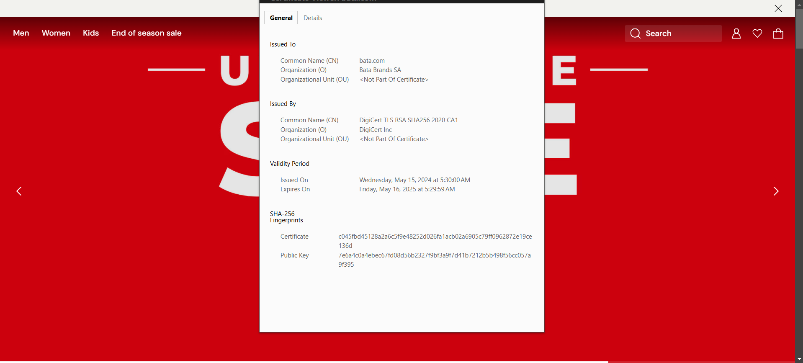

* Ping the main website to get the IP

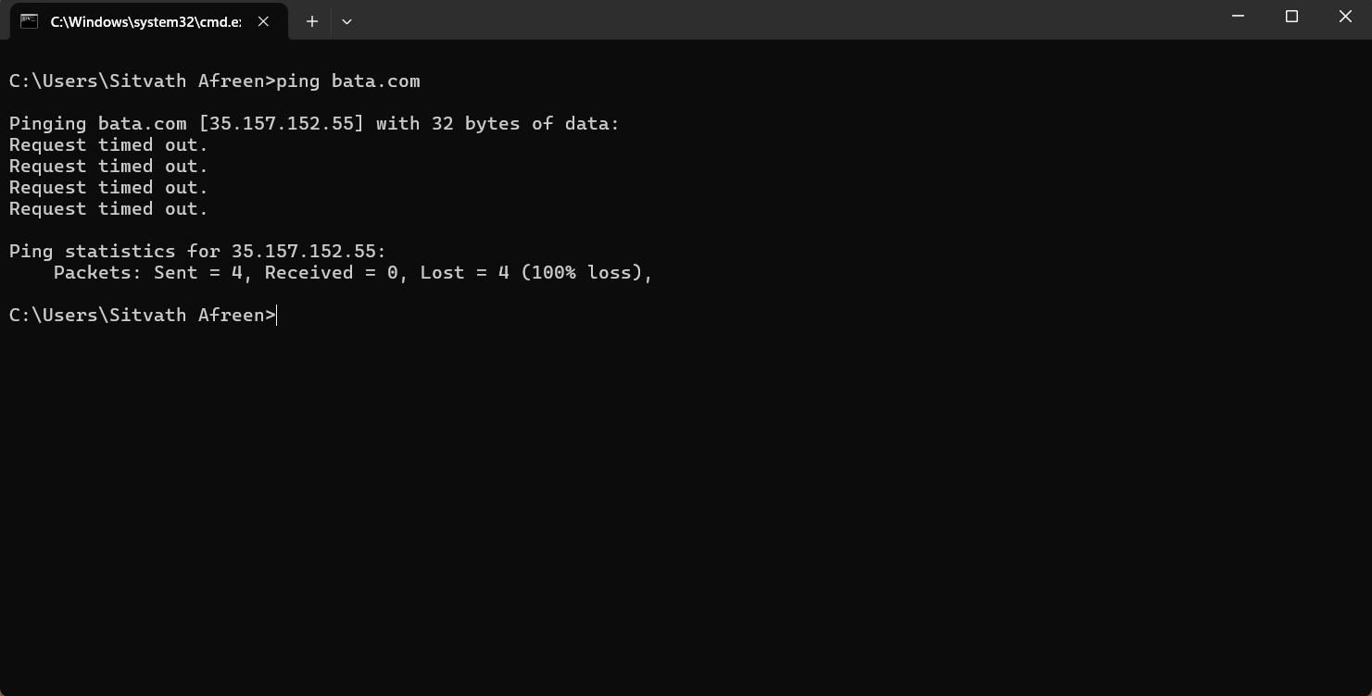

**2. Information of the Domain:**

1. Domain name: bata.com
2. Registry domain id: 223400_DOMAIN_COM-VRSN
3. Domain expiry date: 2026-12-12 T05:00:00Z
4. Cloud Service Provider:- Amazon
5. Web-servers:- Apache, nginx

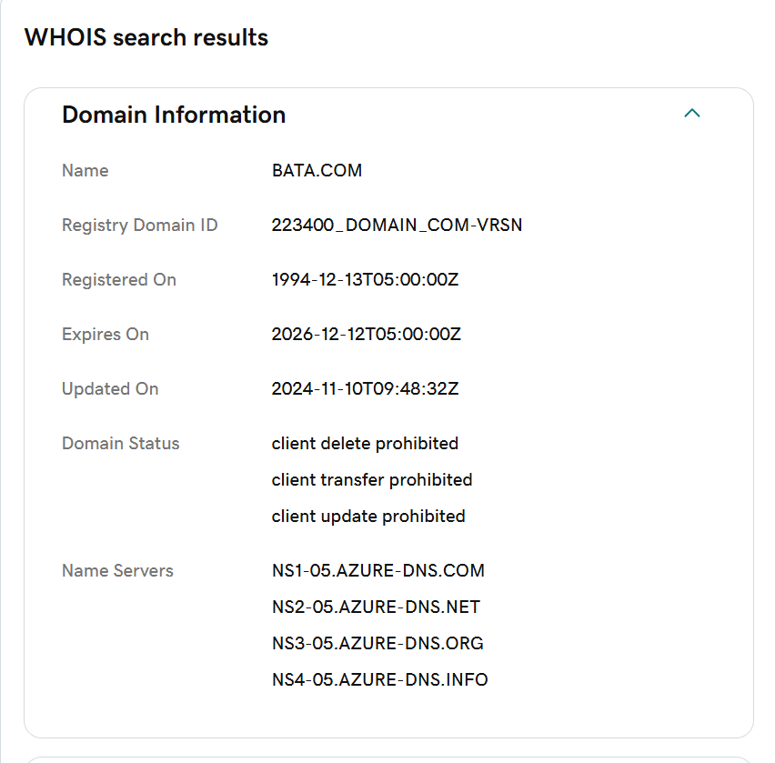

The sub-domains are (crt.sh):

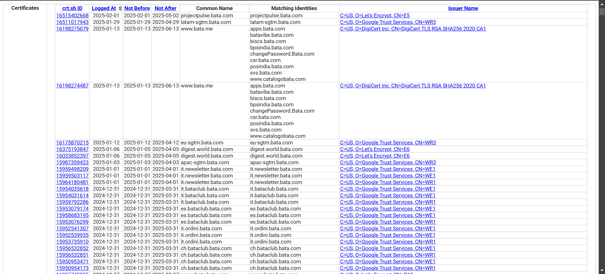

Found Bata pulse management System:- (<URL:->https://projectpulse.bata.com/login)

Did not find any admin pages which is a good sign.

The build with (**builtwith.com**) is goes as follows

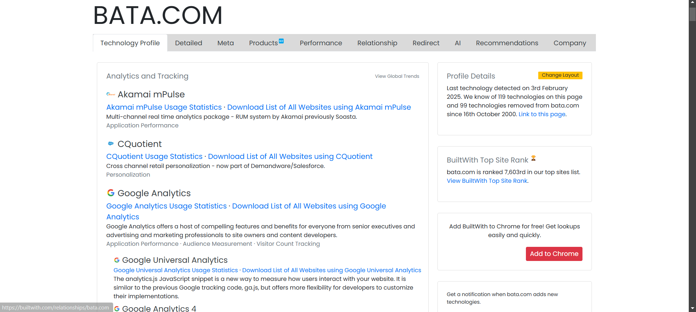

Detected technologies are (with urlscan.io)



There is default redirection from http to https which is a good sign:-

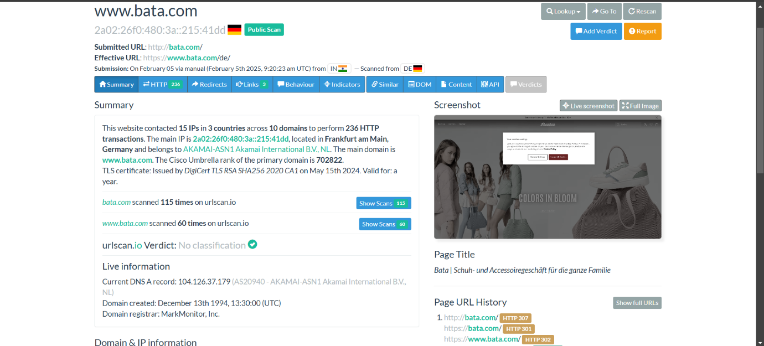

Archive.org:- Past/Historical versions of BATA website

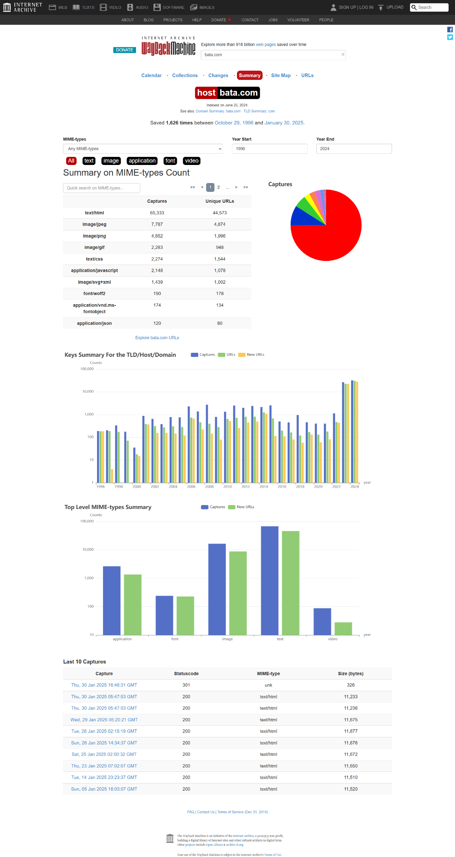

**Recommendations**

* Renew SSL certificate before expiry
* Update outdated frameworks & CDN
* Secure open port (https://iare.ac.in:2083/) to prevent exploitation

Verified its robots.txt and the site is disallowing default redirections which is good.

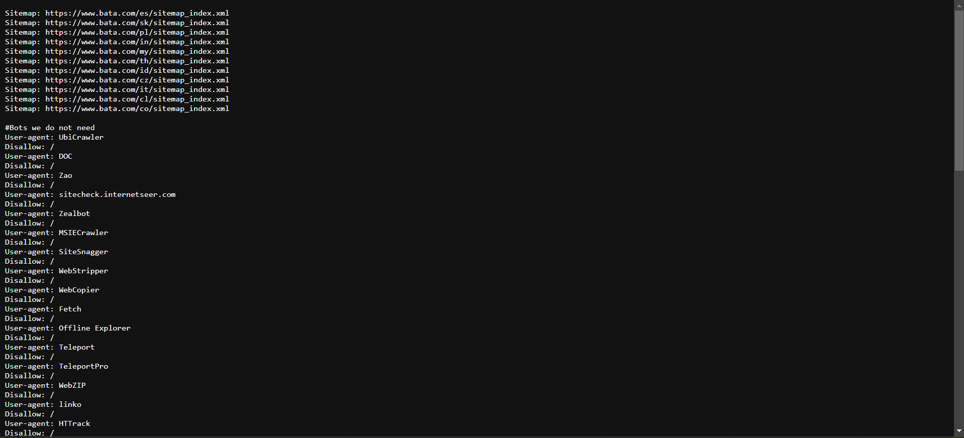

Bata.com Domain health report (by mxtoolbox.com):-

